- Wide Area Networks

Q1. Draw a simple diagram (on paper or using an online tool like draw.io) showing how your phone connects to Instagram's servers from your home WiFi, including the ISP and at least two Wide Area Network (WAN) devices (like routers or switches) in the path?

Answer
- How My Phone Connects to Instagram Through a WAN
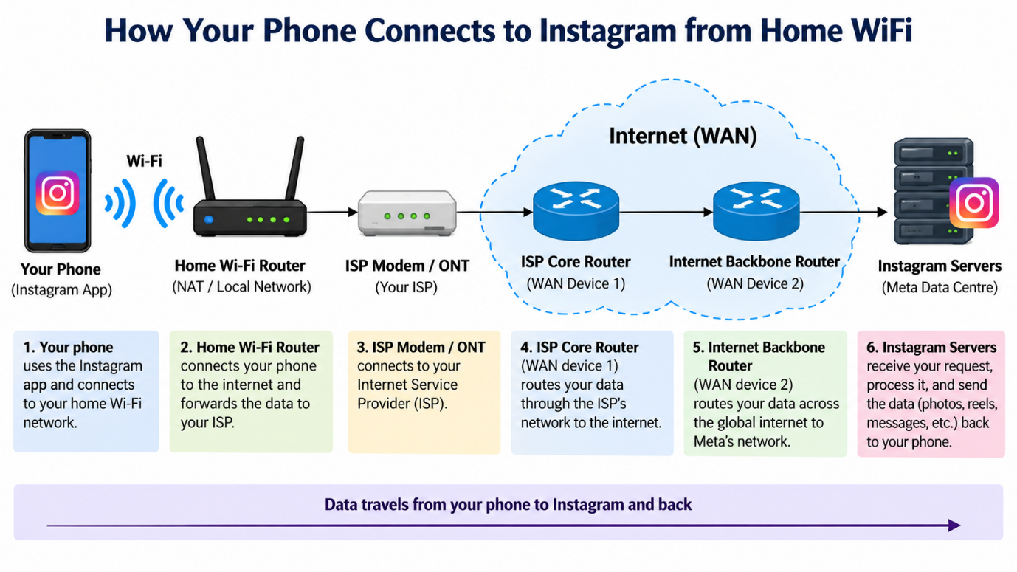
- Explanation:
My phone connects to the home Wi-Fi router using a wireless connection. The router sends the data to the ISP modem/ONT, which forwards it to the Internet Service Provider network. The data then passes through WAN devices such as the ISP Core Router and the Internet Backbone Router before reaching Instagram’s servers. This shows how data travels from a local home network through a WAN to reach an online service.

Q2. Create a table listing three types of WAN technologies (such as MPLS, Leased Line, and Broadband Internet) and compare them based on speed, cost, and where you might see them used in real life (e.g., Zomato office, IRCTC ticketing, your home)?

Answer

- Comparison of WAN Technologies

WAN Technology | Typical Speed | Cost | Real-World Use
- MPLS | High, usually from tens of Mbps to 1 Gbps or more | High | Used by large companies such as Zomato offices to connect multiple branches securely
- Leased Line | High and dedicated | Very High | Used by organisations such as IRCTC, banks, and large offices where a reliable connection is important
- Broadband Internet | Moderate to High | Low to Moderate | Commonly used in homes, small offices, and shops

- Explanation:
MPLS is suitable for large organisations that need secure communication between many branches. A leased line provides a dedicated and reliable connection but is expensive. Broadband internet is cheaper and is commonly used in homes and small offices.

Q3. Research and write a short explanation of how a VPN (Virtual Private Network) uses WANs to let you access apps like Spotify or YouTube securely from a public WiFi at a coffee shop.<br><br><em><strong>Hint:</strong> Focus on how the VPN creates a private tunnel over the public WAN.</em>?

Answer

- How a VPN Uses a WAN Securely
A VPN (Virtual Private Network) creates a secure and encrypted tunnel over a public network such as the internet, which is a WAN. If I connect to public Wi-Fi in a coffee shop and use a VPN, my data is encrypted before it leaves my device.
The encrypted data travels through the public WAN to the VPN server. The VPN server then sends my request to apps such as Spotify or YouTube. This helps protect my information from other users on the same public Wi-Fi and makes the connection more secure.
- Conclusion:
A VPN uses the internet as a WAN but creates a private encrypted tunnel inside it, allowing safer access to online apps and services.

Q4. Imagine Flipkart wants to connect its warehouses in Ahmedabad, Mumbai, and Delhi. Suggest which WAN technology would be best for them and justify your answer with two reasons?

Answer

- Best WAN Technology for Flipkart Warehouses
Recommended WAN Technology: MPLS (Multiprotocol Label Switching)
I would recommend MPLS to connect Flipkart warehouses in Ahmedabad, Mumbai, and Delhi.
- Reason 1 – Reliability:
MPLS provides a stable and dependable connection between multiple locations, which is important for inventory updates, order processing, and warehouse communication.

- Reason 2 – Scalability and Performance:
MPLS can easily connect several branches and support high data traffic. It is suitable for a growing company because new warehouses can be added to the network more easily.

- Conclusion:
MPLS would be a good choice for Flipkart because it offers reliable, secure, and scalable connectivity between warehouses in different cities.

